SLight Setup Instructions and Overview

# Hardware Setup

Equipment needed:

1. Raspberry Pi Computers (At least two for communication)
2. Wires to connect to the GPIO pins of the Pi
3. LEDs to act as streetlights in the demo
4. IR Sensors (Can be replaced by any sensor which detects a car passing)
5. Battery Pack to power the Pi

GPIO Pin Layout:

* LED’s Pin Numbers:
* IR Sensor’s Pin NUmbers: 18,24

Basic Setup Diagram:

Schematic.png

Overhead view of late stage system setup:

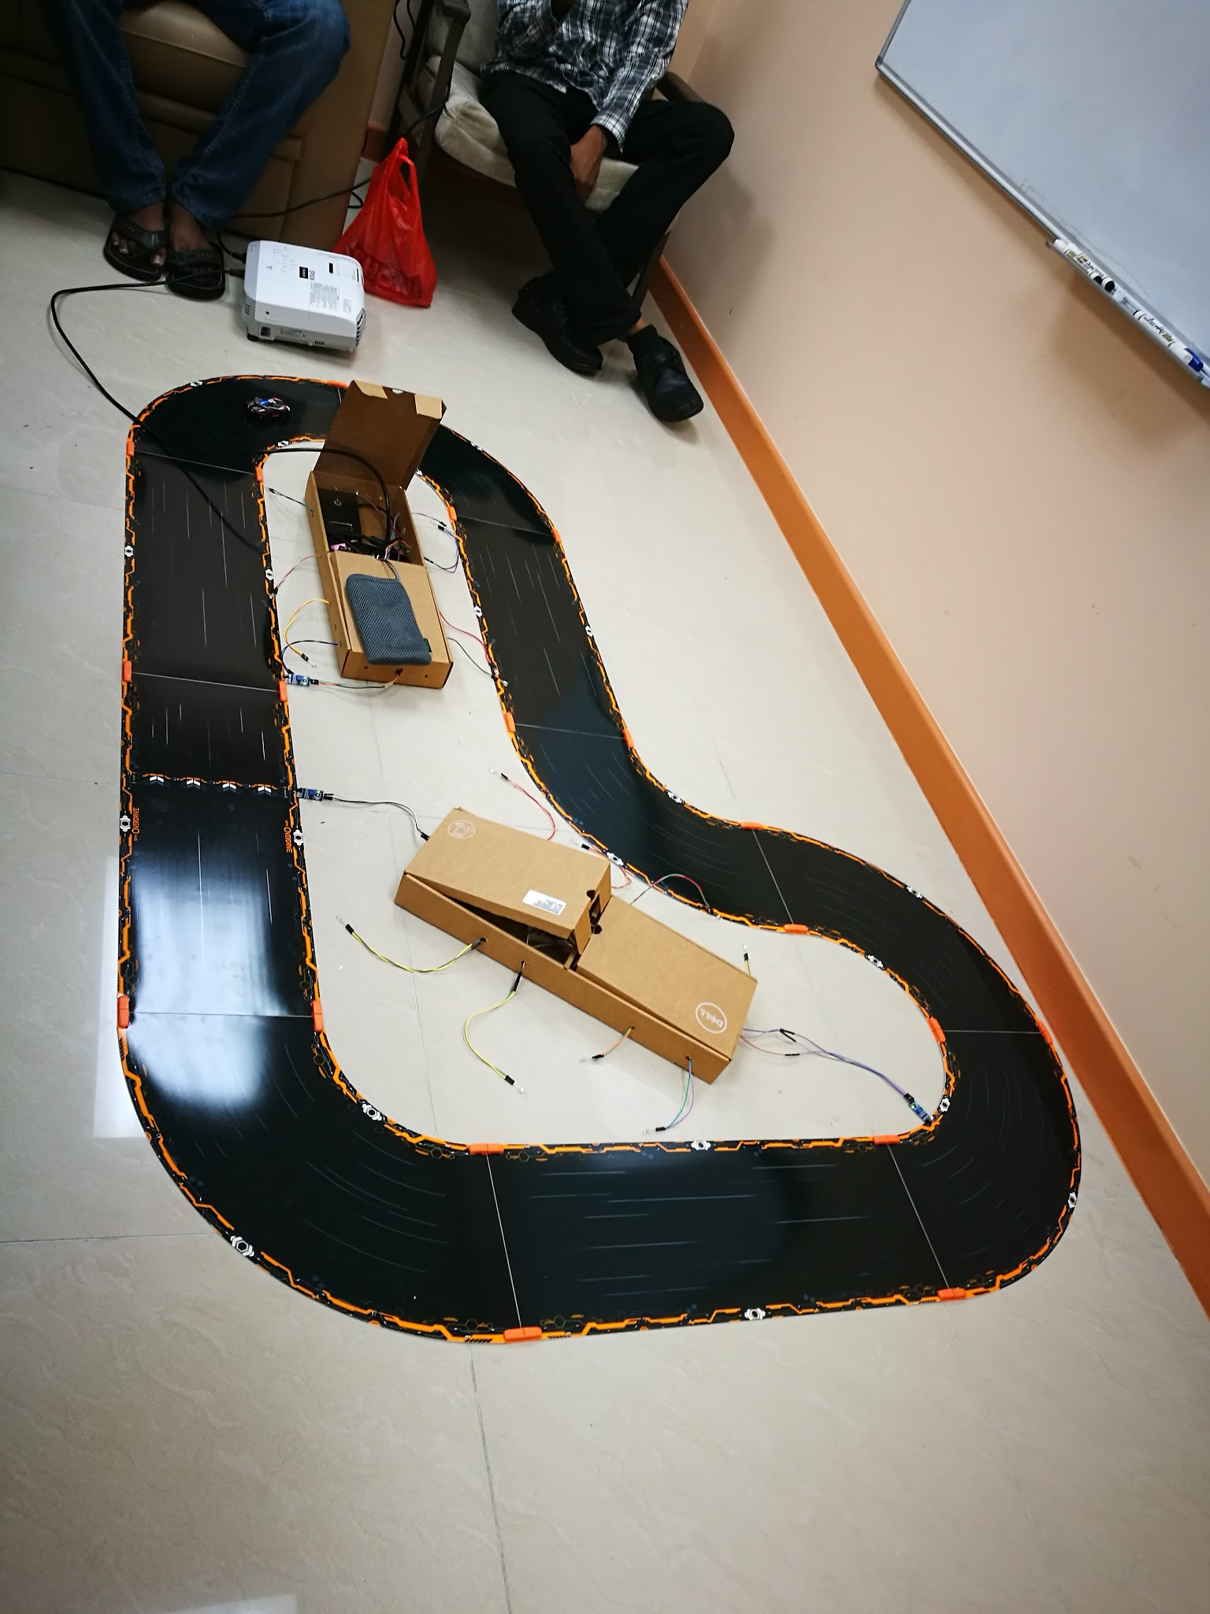

Internal view of system control box:

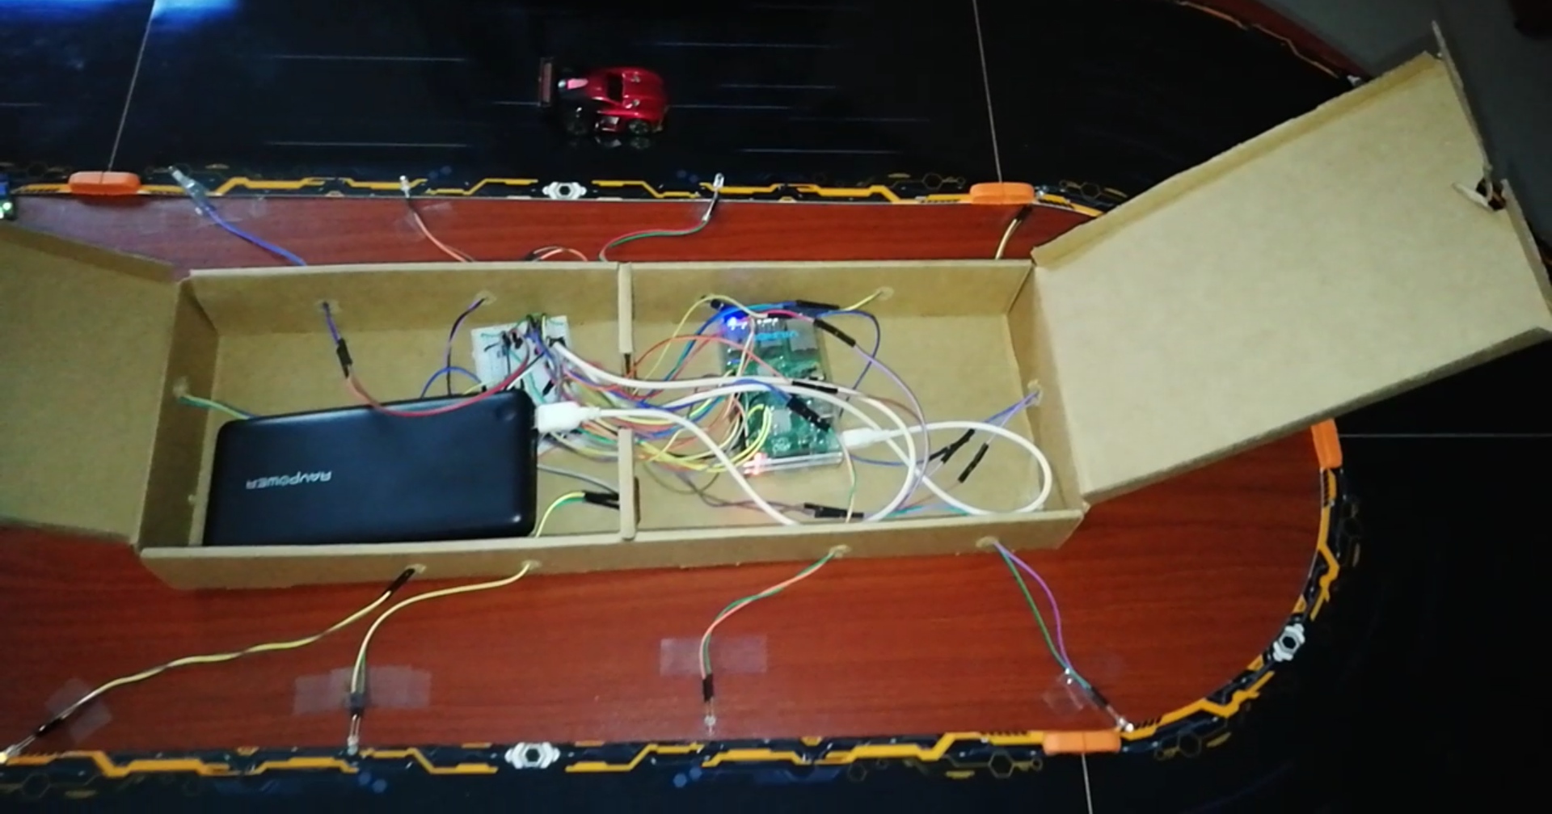

# Raspberry Pi Software Setup

To increase usability:

Multiple pis existing that can be linked together, where each pi must send and receive data to its trailing and leading pis.

To do:

In IPAddresses.txt place amount of pi's linked in circular form on the first line.

For every pi place its IPAddress(hostname -I) in line + 2.

Example the second pi of IPAddress 192.168.3.103 will be placed in line 3

extra new line space at end

Example: for 5 pis:

192.168.3.103

192.168.3.104

192.168.3.105

192.168.3.106

192.168.3.109

run file genClientServer.py to generate the files for each pi

copy the files from the "To Copy" folder and copy directly into the generated/piX folders.

Copy pi folders into pi and enter terminal for that new folder.

Type in terminal "python SLightCore.py"

When all SLightCore.py is running on all pis, the pis will connect together

# Database Overview

The data is hosted on a firebase database which can be found at: <https://prog-c99a8.firebaseio.com/>

# Website Overview

The website was setup with the aid of the following internet technology tools:

* Bootstrap
* Firebase
* Chart.js

Home Page of Website:

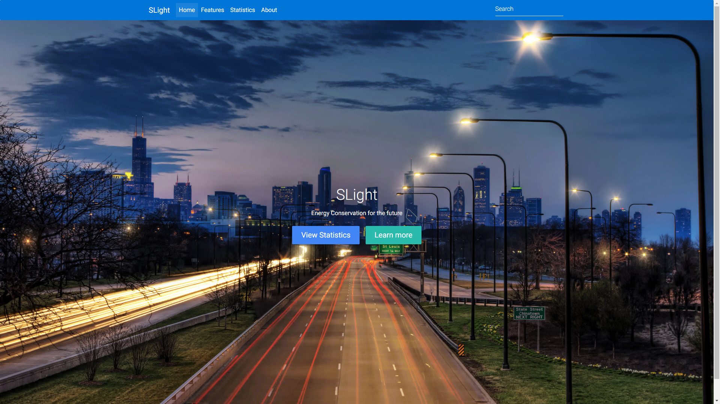

Sample Graph displaying real time data from the database:

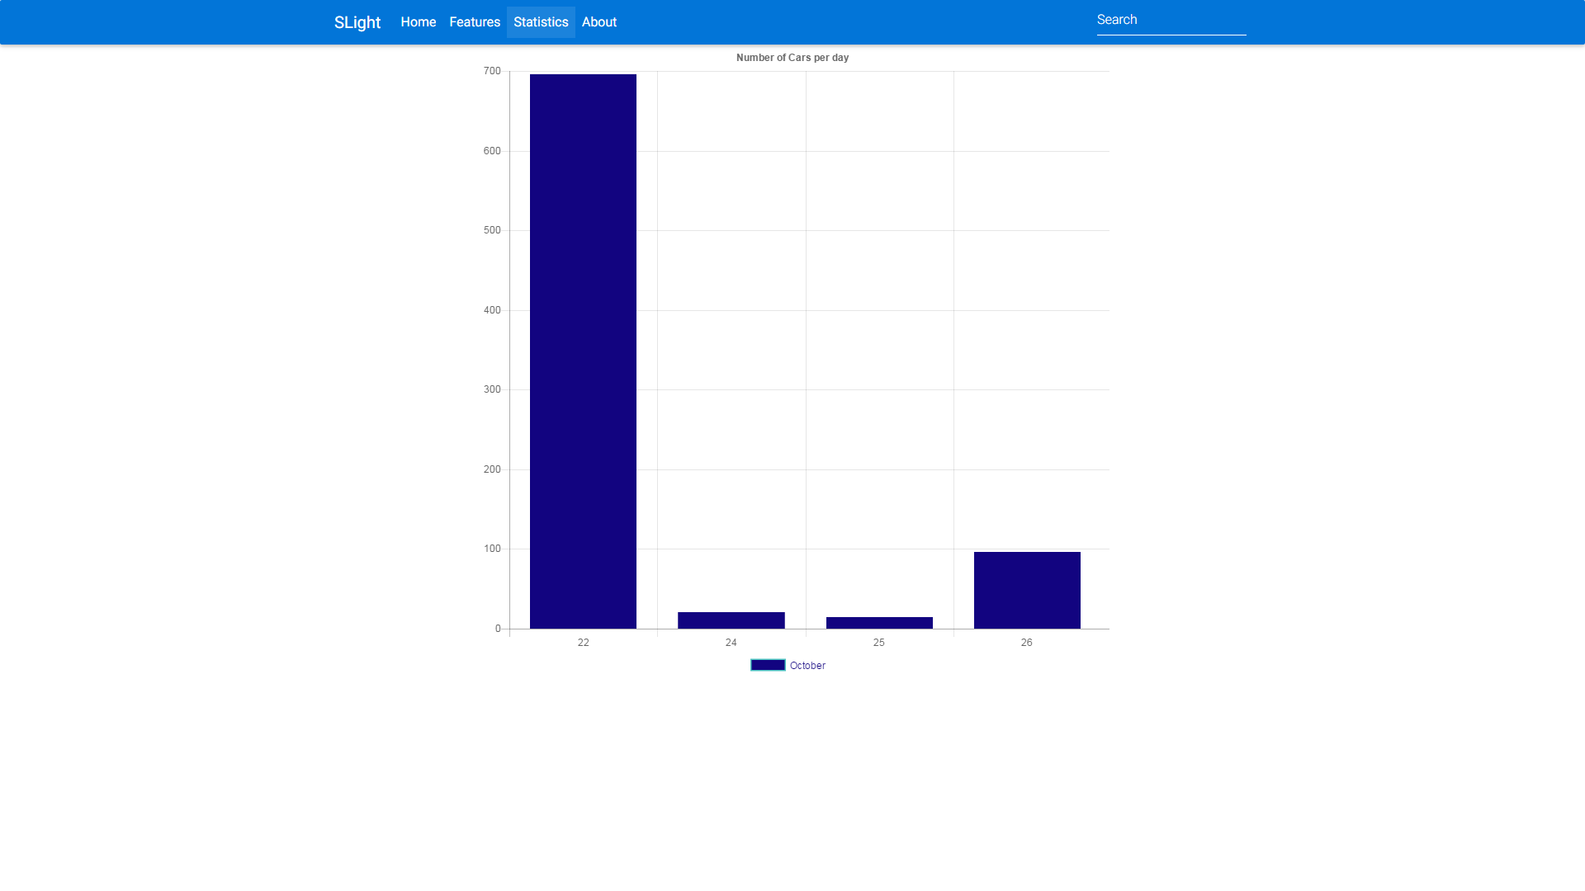

# 

# Car Control Setup

The car control isn’t part of our code, the original github repository has the setup information. See link below.

<https://github.com/anki/drive-sdk/wiki/Getting-Started-on-Ubuntu>

Cars on the track:

